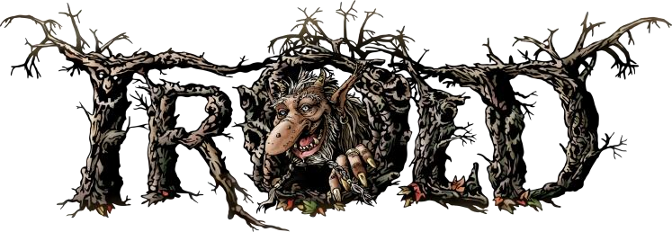

**Hospitality Rider**

TROLD is gonna need a backstage room of a decent size (6 pers.). The room has to be of a normal temperature (around 21 degree) and be free of smoke and clean.

The backstage has to have the following:

* A place to sit and relax for 6 pers. with chairs and table
* A refrigerator that works
* Several 230V power outlets
* Clean towels (minimum 6)
* Toilets for bands/crew

**CATERING:**

Backstage at arrival:

* At least 18 cold beer
* At least 18 cold soda
* Cold water
* A mix of snacks, nuts and chips
* Coffee

**After sound check:**

* Food and the like